Machine Learning
Python assignement-05
Date: 11th may 2026
ABHAY RAJ

Questions: -

Q1. Print elements from a list present at odd index position.
Input: [10,20,30,40,50,60,70,80,90,100]

Q2. Count total no. of digit in a number.
Input: 75869

Q3. Reverse a integer no.
Input: 75869

Q4. Find largest and smallest digit in a given number.
Input:75869

Q5. Find factorial of a no. 5.

Q6. Check Armstrong Number 153.

Q7. Print right angled triangle pattern using a loop.
Input: 5

Q8. Using above Question print decreasing pattern.

Q9. Print alternate no. pattern.
Input: range 1 to 20

Q10. Find common elements (Intersection) using loop.
Given Input:
List_a=[1,2,3,4,5]
List_b=[4,5,6,7,8]

Solutions: -

Q1. Print elements from a list present at odd index position.
Input: [10,20,30,40,50,60,70,80,90,100]
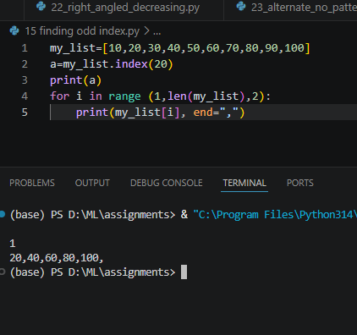

Q2. Count total no. of digit in a number.
Input: 75869
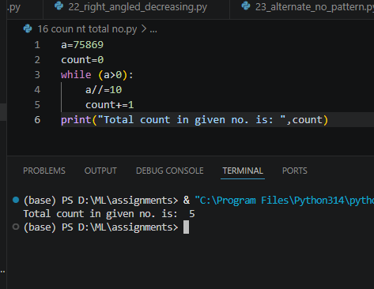

Q3. Reverse an integer no.
Input: 75869
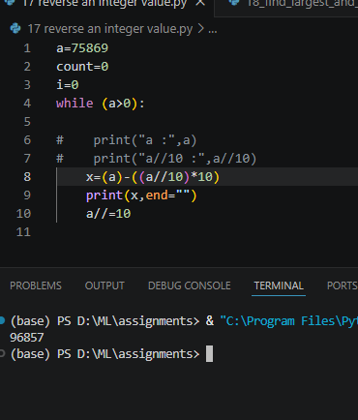

Q4. Find largest and smallest digit in a given number.
Input:75869
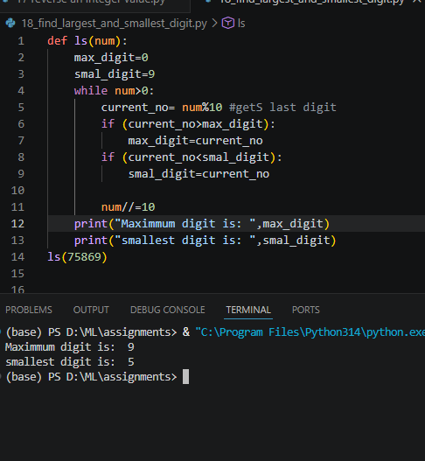

Q5. Find factorial of a no. 5.
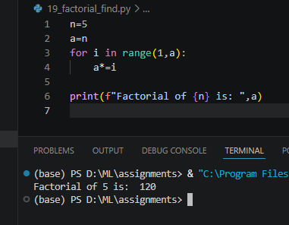

Q6. Check Armstrong Number 153.
Input:
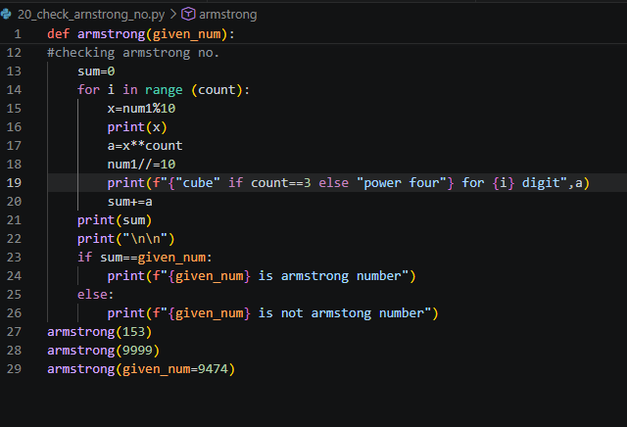
Output:
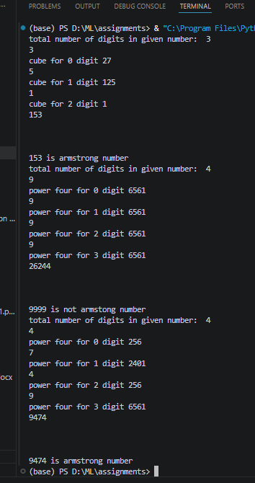

Q7. Print right angled triangle pattern using a loop.
Input: 5
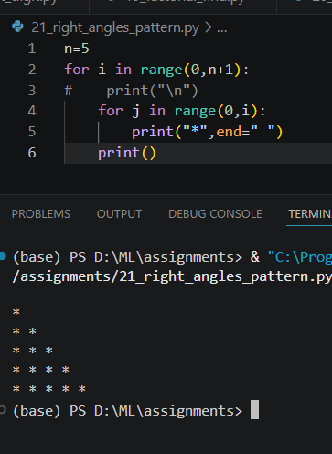

Q8. Using above Question print decreasing pattern.
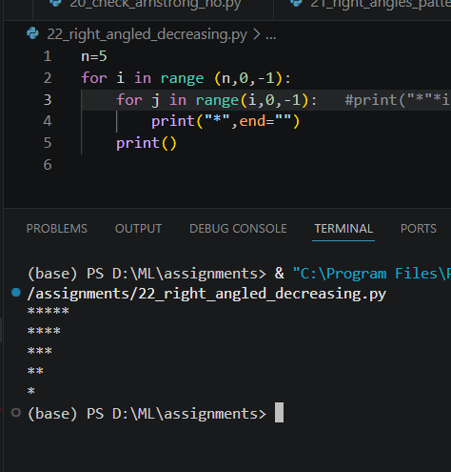

Q9. Print alternate no. pattern.
Input: range 1 to 20
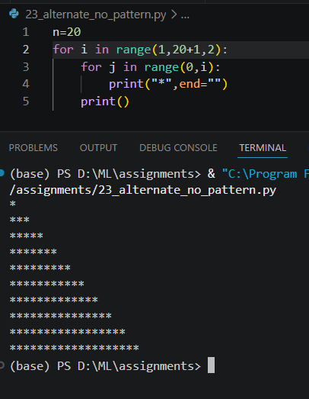

Q10. Find common elements (Intersection) using loop.
Given Input:
List_a=[1,2,3,4,5]
List_b=[4,5,6,7,8]
